ESIOT Assignment No. 10
R (2) | C (4) | V (2) | T (2) | Total (10) | Dated Sign

1.1 Title

Write a server application to be deployed on Raspberry-Pi /Beagle board.

1.2 Problem Definition:

Write a server application to be deployed on Raspberry-Pi /Beagle board. Write client applications to get services from the server application.

1.3 Prerequisite:

Basic of Raspberry-Pi and Python Coding

1.4 Software Requirements:

Raspberry-Pi OS.

1.5 Hardware Requirement:

PIV, 2GB RAM, 500 GB HDD, Lenovo A13-4089Model.

1.6 Theory Concepts:

Sockets- Sockets are the endpoints of a bidirectional communications channel.
Sockets may communicate within a process, between processes on the same machine, or between processes on different continents.
Sockets may be implemented over a number of different channel types: Unix domain sockets, TCP, UDP, and so on.
The socket library provides specific classes for handling the common transports as well as a generic interface for handling the rest.
To create a socket, you must use the socket.socket() function in socket module, which has the general syntax:
s = socket.socket (socket_family, socket_type, protocol=0)
socket_family: This is either AF_UNIX or AF_INET.
socket_type: This is either SOCK_STREAM or
SOCK_DGRAM.
protocol: This is usually left out, defaulting to 0.
Once you have socket object, then you can use required functions to create your client or server program.
Server Socket Method
s.bind() This method binds address (hostname, port number pair) to socket.
s.listen() This method sets up and start TCP listener.
s.accept() This passively accept TCP client connection, waiting until connection arrives (blocking).
s.connect() This method actively initiates TCP server connection.
s.recv() This method receives TCP message
s.send() This method transmits TCP message
s.recvfrom() This method receives UDP message
s.sendto() This method transmits UDP message
s.close() This method closes socket
socket.gethostname() Returns the hostname.
How the Communication between socket is taken place,
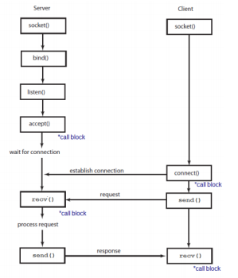

1.7 Conclusion- after completion of this assignment students are able to understand how the client and server can communicate to each other via socket and exchange the data.

1.8 Assignment Questions

1. What is the difference between TCP and UDP?
2. Explain how TCP Works?
3. Explain how UDP Works?

References:- 1. http://mitu.co.in

